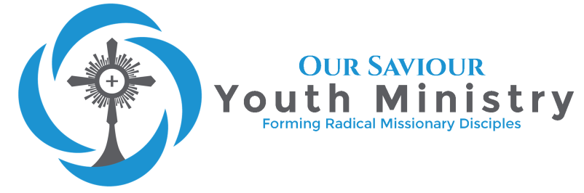
“Do not conform yourselves to this age but be transformed by the renewal of your mind, that you may discern what is the will of God, what is good and pleasing and perfect” Romans 12:2

Our Saviour’s Religious Education
2018-2019 FAMILY INFORMATION
Religious Education Classes Begin Sunday, August 12th, 2018

All students 7th-12th are invited to join Our Saviour Youth Ministry as we grow in our faith and love for Jesus Christ. We have several different programs for each grade level.
For 7th-8th grade students, we have our Edge program. Edge is designed for middle school students to help them dive deeper into the truth of our Faith. We will meet Sunday mornings from 9_{am}-10_{am}. After prayer in the school courtyard, we will meet in the Upper Room for sessions packed with activities and times of encounter with God and His Church.
For 9th-12th grade students, we have Life Teen. Life Teen is a program designed for high schoolers to help them grow in their faith and learn about the Church and the Lord in an interactive environment. We will meet Sunday evenings from 6_{pm}-7:30_{pm}. We meet in the Upper Room and each session will also be full of games and lessons created for teens.
Confirmation Preparation is for those who wish to complete the Sacrament of Confirmation in that school year. Students who have not been enrolled at a Catholic school must complete two years of Religious Education Formation or meet with the Youth Minister during the Preparation year.

TO REGISTER
Complete front and back of Registration Form and submit fee
if applicable to the Parish Office or submit an email;
Our Saviour’s Catholic Church, 5301 N. Atlantic Av. Cocoa Beach, FL 32931
Office hours: Monday-Friday 9:00am-5:00pm
Email contact: aell@oursavioursparish.org
FEES
7th through 8th Grade: $ 45 - one child; $ 80 - two children; $ 100 - family of 3 or more
Confirmation Preparation: $90 per child
Please make checks payable to Our Saviour’s Catholic Church.
† Religious Education at Our Saviour’s is for all children, regardless of their family’s ability to pay.
If you are unable to pay the full fee at registration, please speak with the Director of Religious Education.
All financial matters are kept confidential.
CURRICULUM
Our Religious Education Program is an engaging and doctrinally sound religion curriculum that helps today’s children discover the beauty and truth of our Catholic faith

Our curriculum integrates with the standards and requirements of the Diocesan Curriculum Framework. You can view the standards for each grade level by going to:
http://www.seattlearchdiocese.org/cff/re/rek8.aspx

For information about Life Teen and Edge, and for important resources for you, visit http://lifeteen.com.

